Ques 1:Prompt for amount, interest rate and no. of years and calculate simple interest.

<!DOCTYPE **html**>

<**html**>

<**head**>

<**meta charset="utf-8"**>

<**title**>Question-1</**title**>

</**head**>

<**body**>

<**script src="./intrest.js" charset="utf-8"**></**script**>

<**script**>*intrest*() </**script**>

</**body**>

</**html**>

**function** *intrest*()

{

**var** amount = *prompt*(**"Enter the amount"**);

**var** intrest = *prompt*(**"Enter the intrest rate"**);

**var** year = *prompt*(**"Enter the number of year"**);

**var** months = *prompt*(**"Enter the number of months"**);

**var** days = *prompt*(**"Enter number of days"**);

**var** S_I = ((amount * intrest * year) + (amount * intrest * months % 12) + (amount * intrest * days % 365)) / 100;

***document***.write(S_I);

}

Ques 2:Javascript program to check palindrome string.

Ans:

<!DOCTYPE **html**>

<**html lang="en"**>

<**head**>

<**meta charset="UTF-8"**>

<**script src="palindrome.js"**></**script**>

</**head**>

<**body**>

<**div** >

<**input id="word" placeholder="Enter the String " required type="text "**>

<**button name="Calculate" onclick="***palindrom*()**"**>Check</**button**>

</**div**>

</**body**>

</**html**>

**function** *palindrom*() {

**var** test = ***document***.getElementById(**"word"**).**value**;

**var** result = **""**;

**for** (**var** index = test.**length** - 1; index >= 0; index--) {

result = result.concat(test[index]);

}

**if** (result === test) {

*alert*(**"Yes,Pallindrome"**);

}

**else** {

*alert*(**"notPallindrome"**);

}

}

**Ques 3:JAVAscript program to calculate area of circle**

<!DOCTYPE **html**>

<**html lang="en"**>

<**head**>

<**meta charset="UTF-8"**>

<**script src="areaCircle.js"**></**script**>

<**link rel="stylesheet" type="text/css" href="intrest.css"**>

</**head**>

<**body**>

<**div class=" maindiv"**>

<**form class="Box"** >

<**input type="text " placeholder="Enter the Radius " pattern="[0-9]+\.[0-9]{2}" required id="radius"**>

<**button name="Calculate" onclick="***circleArea*()**" value="submit"**>Calculate</**button**>

</**form**>

</**div**>

</**body**>

</**html**>

**function** *circleArea*() {

**var** r =***document***.getElementById(**'radius'**).**value**;

**var** areaCircle = 3.14*r*r;

*alert*(**"Area of Circle : "**+areaCircle);

}

Ques 4: Copy information of one object to another and log it to console.

<!DOCTYPE **html**>

<**html**>

<**head**>

<**meta charset="utf-8"**>

<**title**>Question-4</**title**>

</**head**>

<**body**>

<**script src="copydata.js" charset="utf-8"**></**script**>

</**body**>

</**html**>

**const *square***={

**side**: 1,

area(){

***console***.log(**'area'**);

}

};

***console***.log(**"content of square :"**+ ***square***);

***console***.log(***square***);

**var *clonesquare*** ;

***console***.log(**"content of clonesquare before copy : "**+ ***clonesquare***);

***clonesquare*** = ***Object***.assign({},***square***);

***console***.log(**"content of clonesquare after copy : "**+ ***clonesquare***);

***console***.log(***clonesquare***);

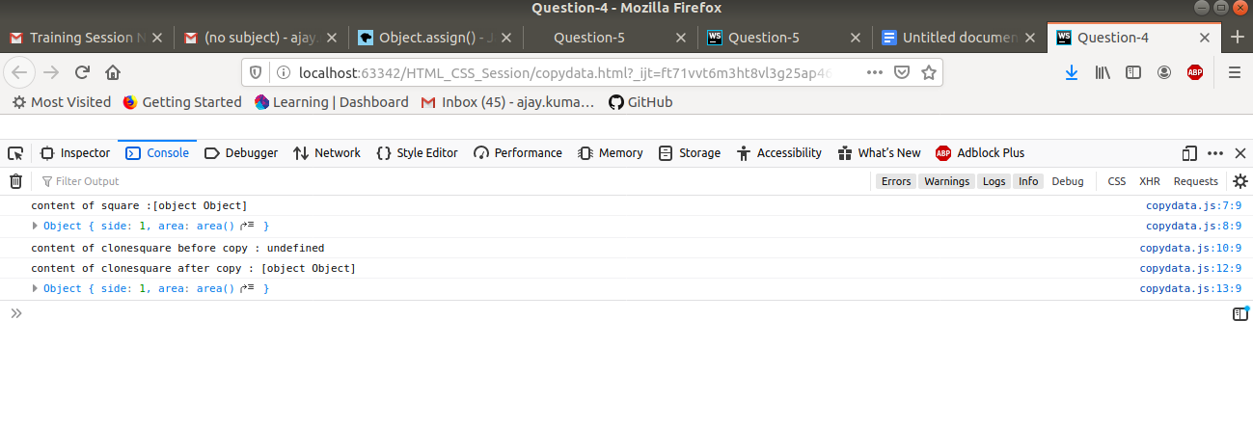

Ques 5: Create a object with following details :

* Name, age, salary ,DOB
* filter all employees with salary greater than 5000
* group employee on the basis of their age
* fetch employees with salary less than 1000 and age greater than 20.Then give them an increment 5 times their salary.

<!DOCTYPE **html**>

<**html**>

<**head**>

<**meta charset="utf-8"**>

<**script src="./employee.js" charset="utf-8"**></**script**>

<**title**>Question-5</**title**>

</**head**>

<**body**>

Answer 5:

</**body**>

</**html**>

**var *list*** =[];

**for**(**let *i***=0; ***i***<2; ***i***++) {

**var *employee*** ={};

***employee***[**'name'**]=*prompt*(**"Enter the name"**);

***employee***[**'age'**]=*prompt*(**"Enter age"**);

***employee***[**'salary'**]=*prompt*(**"Enter Salary"**);

***employee***[**'DOB'**]=*prompt*(**"Enter DOB"**);

***list***.push(***employee***);

}

***console***.log(***list***);

*//filter all employees with salary greater than 5000*

***console***.log(**"Name,salary"**);

**var *list*** =[{**Name**:**"Harsh"**,**Age**:21,**salary**:15000,**DOB**:**"31/08/1998"**},

{**Name**:**"Kshitiz"**,**Age**:22,**salary**:22500,**DOB**:**"20/04/1997"**},

{**Name**:**"Aditya"**,**Age**:23,**salary**:600,**DOB**:**"22/02/1996"**},

{**Name**:**"Ajay"**,**Age**:22,**salary**:750,**DOB**:**"26/02/1991"**},

{**Name**:**"Harshul"**,**Age**:22,**salary**:4000,**DOB**:**"7/08/1979"**},

{**Name**:**"Tony Stark"**,**Age**:26,**salary**:800,**DOB**:**"12/02/1981"**},

{**Name**:**"Hritik "**,**Age**:35,**salary**:98000,**DOB**:**"12/10/1970"**},

{**Name**:**"Amit "**,**Age**:43,**salary**:69000,**DOB**:**"16/12/1976"**},]

**for**(**let *i***=0; ***i***<***list***.**length**; ***i***++)

{

**if**(***list***[***i***].**salary** > 5000)

{

***console***.log(***list***[***i***].**Name**,***list***[***i***].**salary**);

}

}

*//update the salary whos aoge is >20 years and salary is less than 1000*

***console***.log(**"Name salary Updated_Salary"**);

**for**(**let *i***=0; ***i***<***list***.**length**; ***i***++)

{

**if**(***list***[***i***].**salary**<1000 && ***list***[***i***].**Age** >20)

{

**var *new_salary***=5\****list***[***i***].**salary**;

***console***.log(***list***[***i***].**Name**,***list***[***i***].**salary**,***new_salary***);

}

}

